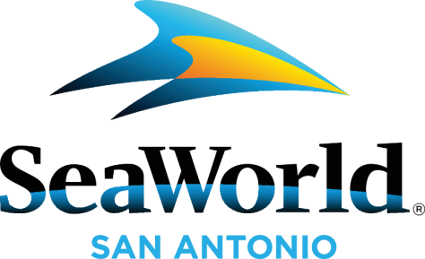

MEDIA ADVISORY
January 7, 2023
FOR IMMEDIATE RELEASE
SeaWorld’s ‘Inside Look’ Gives Guests Exclusive, Behind-The-Scenes Access to Animals
- Annual event offers unique behind-the-scenes experiences with people and places inside the park not generally available to the public
- A wide range of specialists talk with guests about what it takes to care for the park’s diverse animal populations including dolphins, sharks, whales and more
- Rescue teams share more about their work including critical care and rehabilitation for injured and orphaned animals
- Guests can purchase tickets for as low as 49.99!

WHAT: Go behind the scenes and get an all-access look into the habitats of your favorite animals including orcas, sea lions, sea turtles, aquarium fishes, and small terrestrial mammals during SeaWorld San Antonio’s Inside Look. As part of the event, SeaWorld has created Inside Look locations throughout the park where animal care experts will share specifics about the park’s mission to provide extraordinary care to its animals, to rescue animals in need, and to help rehabilitate them so they can return to the wild. Guest will also learn what they can do to protect animals and the environment. This one-of-a-kind event is sure to inspire young and old! Inside Look is free with park admission and will bring together park guests, the incredible SeaWorld zoological staff members, and the park’s amazing animals.

Guests wanting to visit during Inside look can purchase tickets for as low as $49.99 or, for an even better deal, purchase a pass for as low as $6.99 a month and enjoy year-round animals, events, rides, free parking, and other unbeatable benefits. Pass Members will also have the opportunity to be among the first to ride the all-new Catapult Falls, the world's first launched flume coaster, opening in 2023!

WHEN: January 7th - 8th 2023, 10:30am – 5pm

WHERE: SeaWorld San Antonio
ABOUT: SeaWorld Entertainment, Inc. (NYSE: SEAS) is a leading theme park and entertainment company providing experiences that matter, and inspiring guests to protect animals and the wild wonders of our world. The Company is one of the world’s foremost zoological organizations and a global leader in animal welfare, training, husbandry, and veterinary care. The Company collectively cares for what it believes is one of the largest zoological collections in the world and has helped lead advances in the care of animals. The Company also rescues and rehabilitates marine and terrestrial animals that are ill, injured, orphaned, or abandoned, with the goal of returning them to the wild. The SeaWorld® rescue team has helped more than 40,000 animals in need over the Company’s history. SeaWorld Entertainment, Inc. owns or licenses a portfolio of recognized brands including SeaWorld®, Busch Gardens®, Aquatica®, Sesame Place® and Sea Rescue®. Over its more than 60-year history, the Company has built a diversified portfolio of 12 destination and regional theme parks that are grouped in key markets across the United States, many of which showcase its one-of-a-kind zoological collection. The Company’s theme parks feature a diverse array of rides, shows and other attractions with broad demographic appeal which deliver memorable experiences and a strong value proposition for its guests.

CONTACT: Please RSVP Chuck.Cureau@SeaWorld.com
210-842-4825
###

